**BASIC CI/CD DEMO WITH JENKINS:**

This project will demonstrate the continuous integration of code to github and continuous delivery through cloud. We will automate this CICD with jenkins

1. The project is ready in local and github named test-demo4.

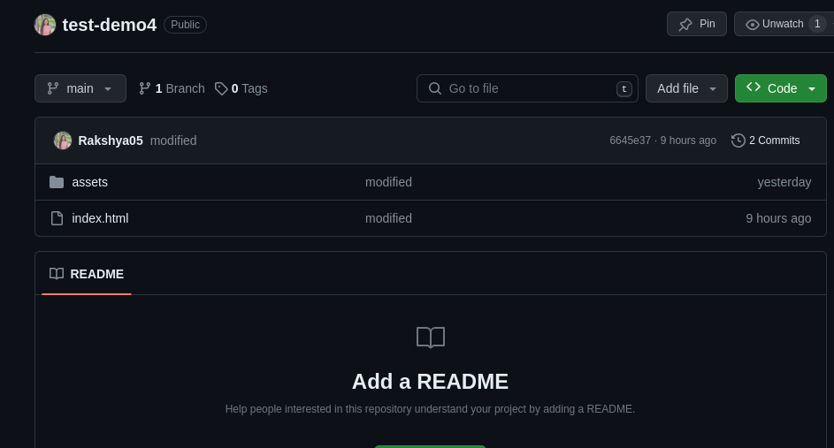

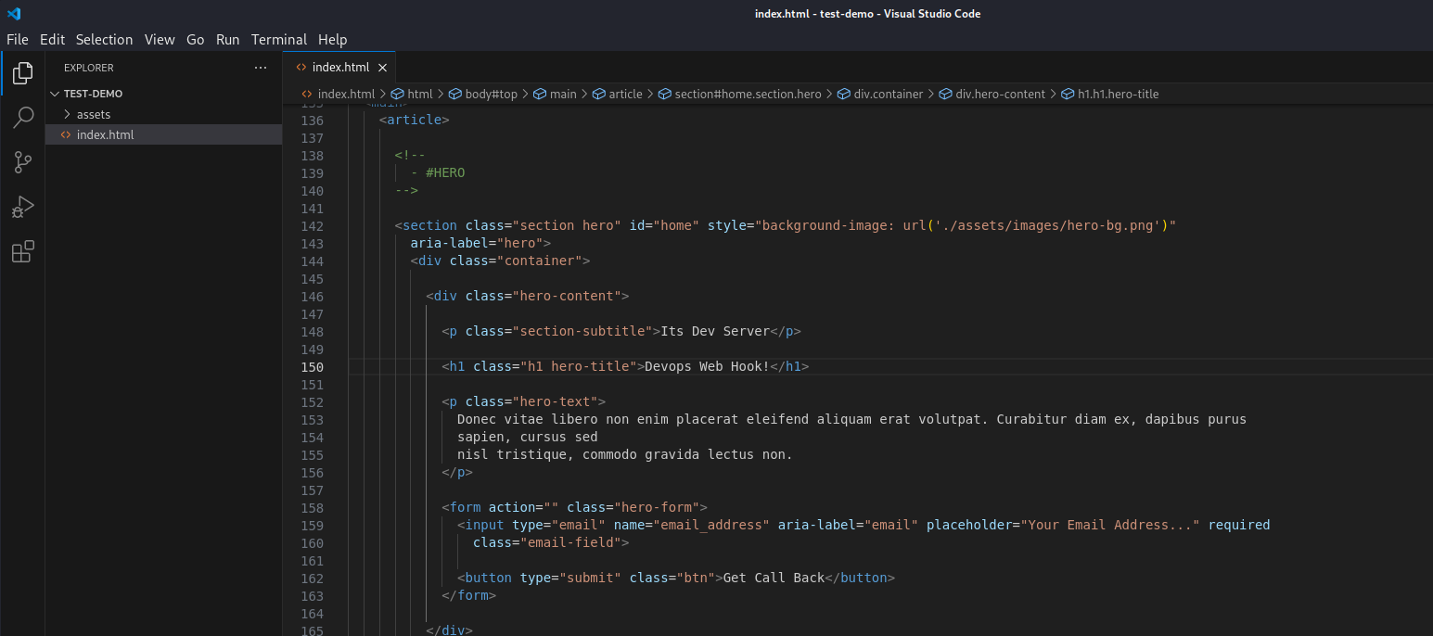

1. First create two EC2 instances one for a web server and another for a jenkins setup.

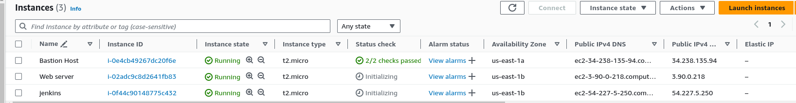

1. Now connect to web server ec2 from terminal and update && upgrade

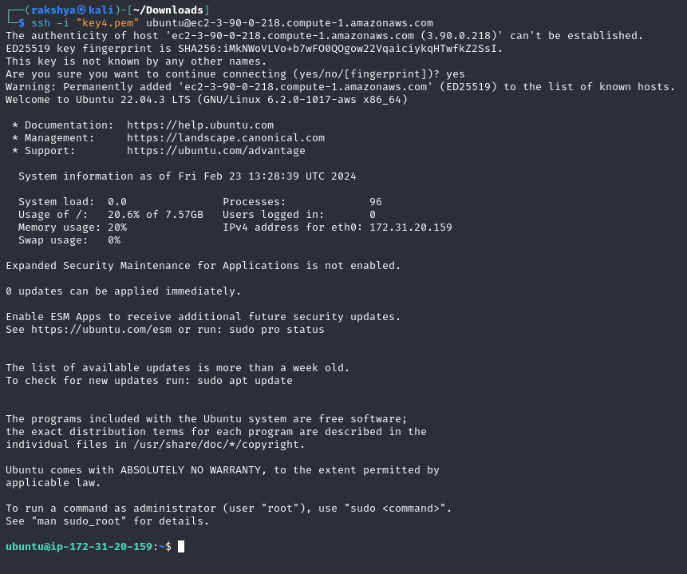

1. Install nginx in web server ec2 instances

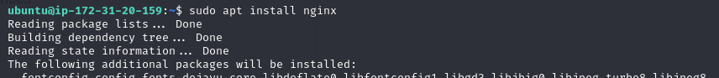

1. Create new folder in /var/www location for project storage.

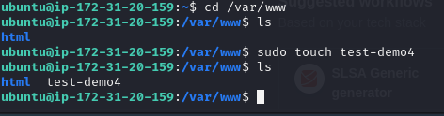

1. Go to location /etc/nginx/sites-available for the configuration changes so that the nginx file will run from our new project test-demo4

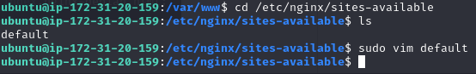

1. Change the location with folder name from html

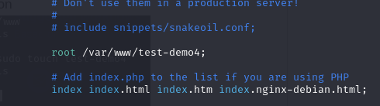

1. Change the permission for project folder.

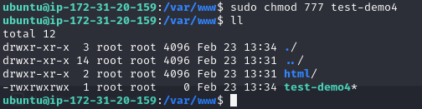

1. Now connect to jenkins ec2 instance from terminal and update && upgrade it.

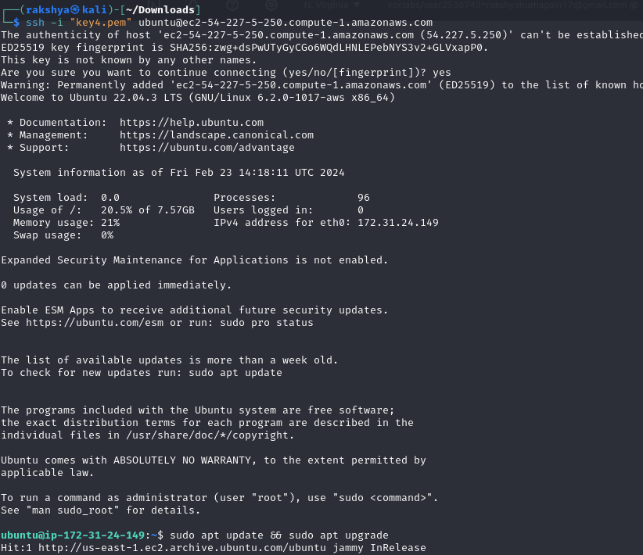

1. Download jenkins from documentation present in following link.

<https://www.jenkins.io/doc/book/installing/linux/>

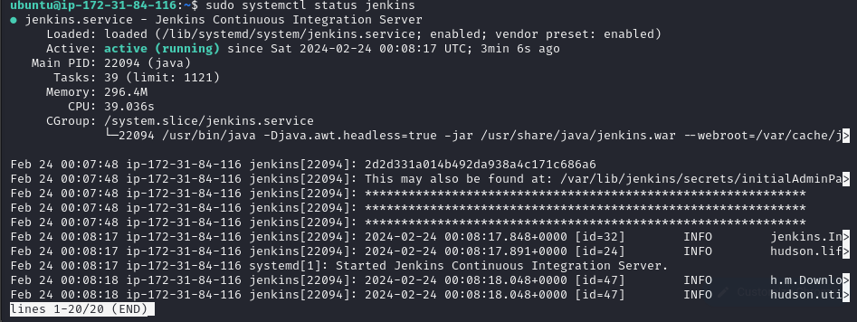

Note: Installation of java is necessary for installation of jenkins.

1. open jenkins port from inbound security group.of jenkins ec2 instance.

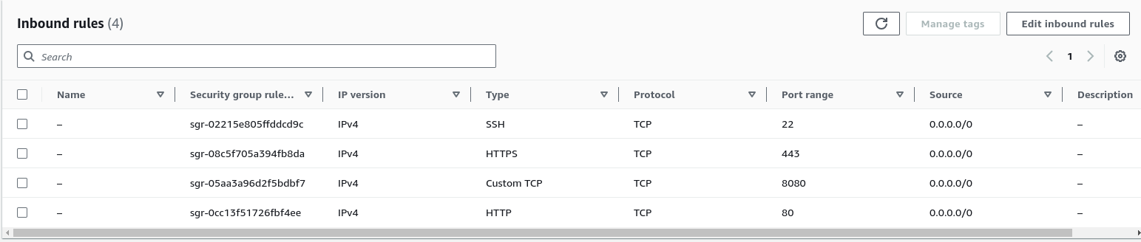

1. After installation, Connect jenkins through browser using ip and port.

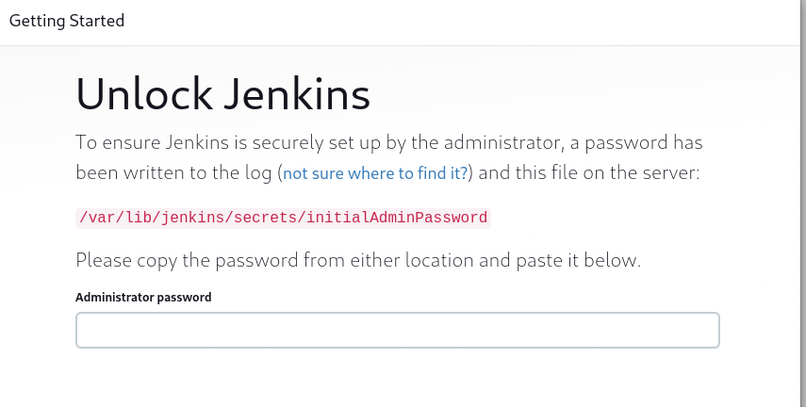

1. Add password which is located in following location



1. Recommended install suggested plugins

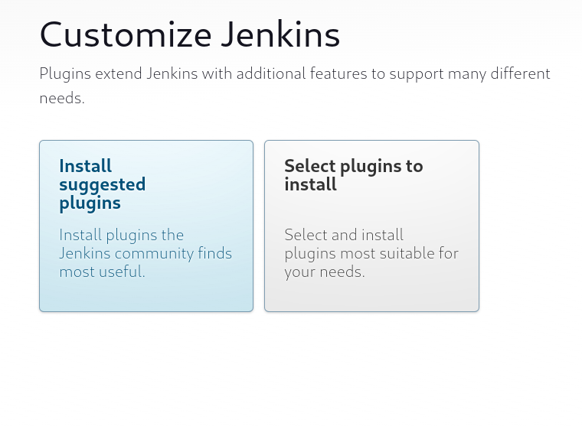

1. Create user and password and save it for an future user

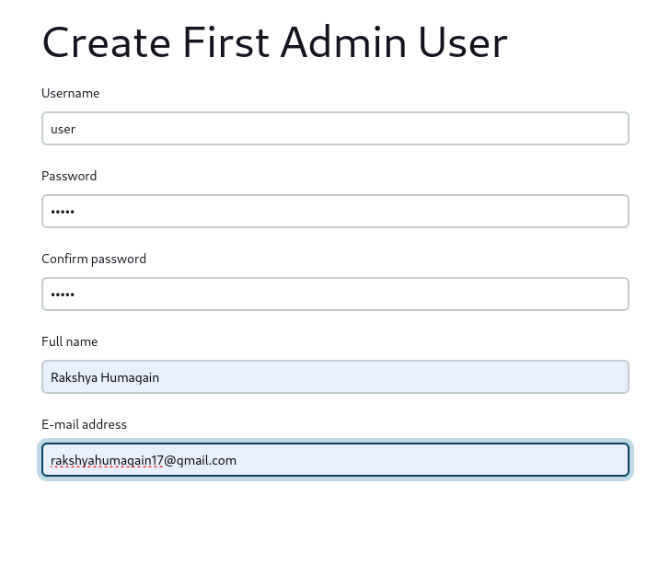

1. Save url for future use

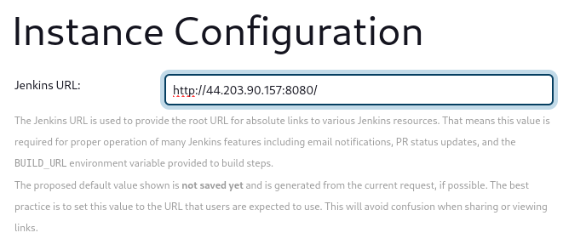

1. Now we finished the setup of jenkins and jenkins dashboard is visible.

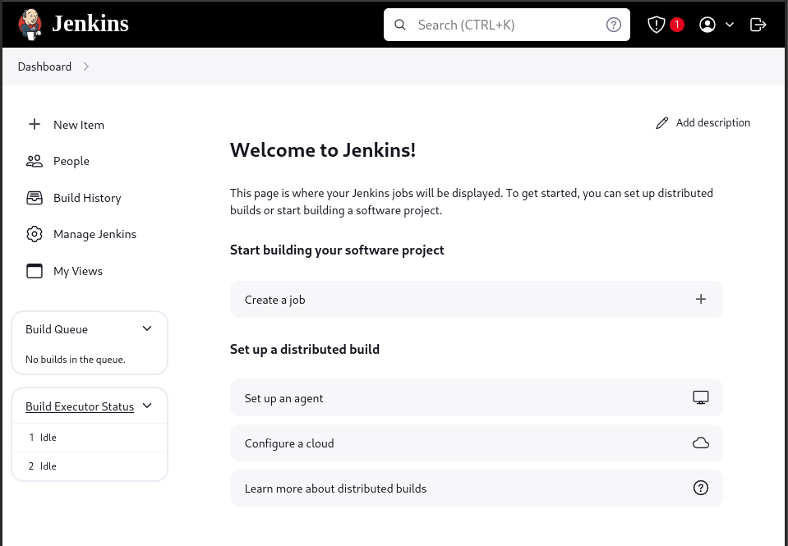

1. Add necessary plugins “Publish over ssh” .Naviagate through manage jenkins and Available plugins. Choose “publish over ssh” and install it.

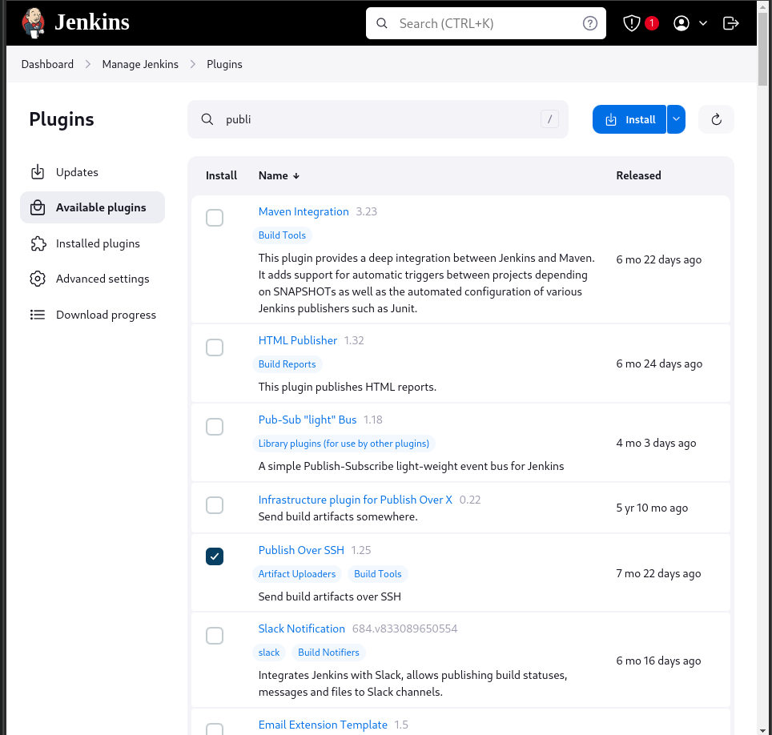

Note: it is necessary for automation.

1. Now, we can connect jenkins with a Web server Ec2 instance. Navigate through manage jenkins and system and Scroll down upto plugins.

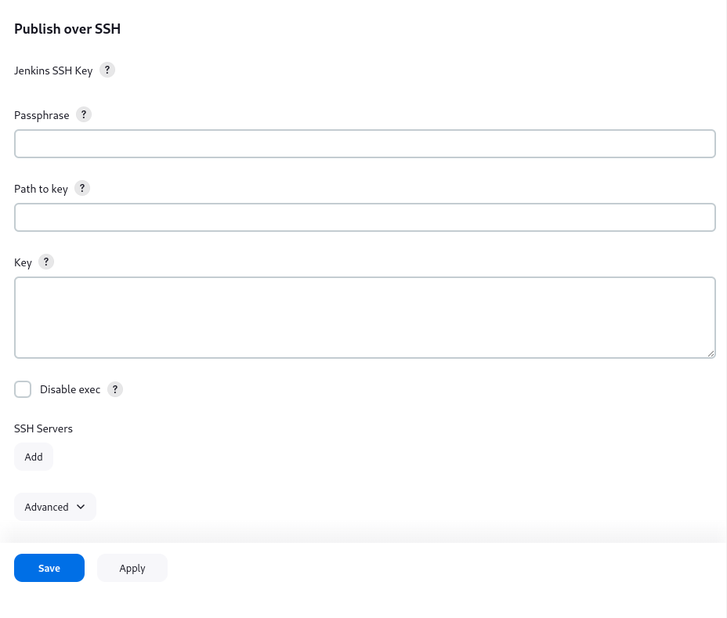

1. Add key content of ec2 instance to key of plugins.

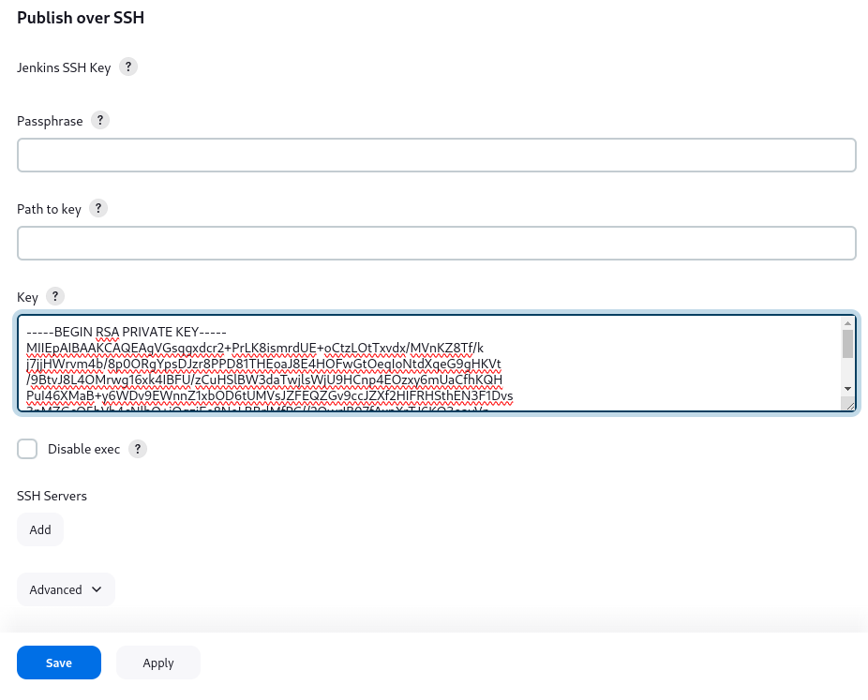

1. Add an ssh server with the name,hostname,username and remote directory.

Add name as wish

Add public ip of web server in hostname

Add instance platform in username.

Add filename where the code will be placed in a remote directory.

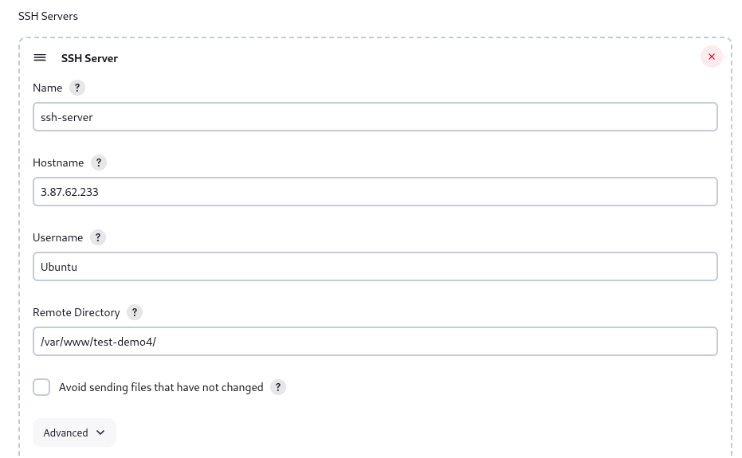

1. Test configuration for success and apply it.

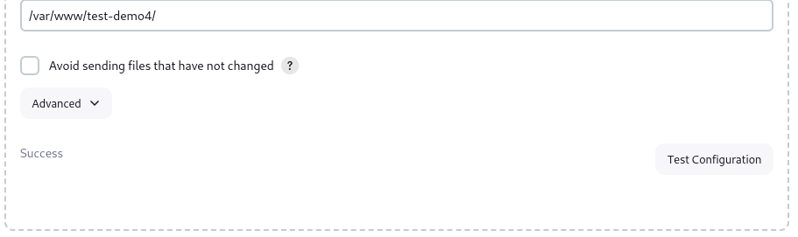

1. Now,the connection between git and jenkins is establish.
2. Navigate through new items and name it. Choose freestyle
3. 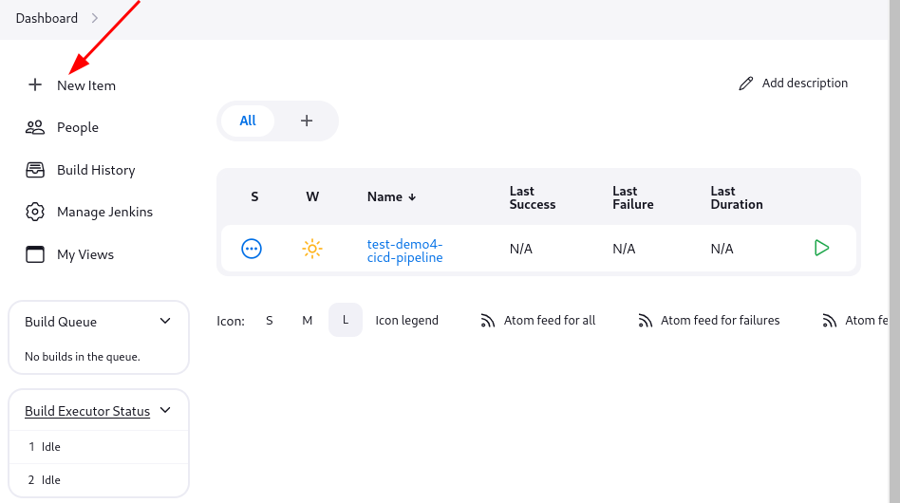

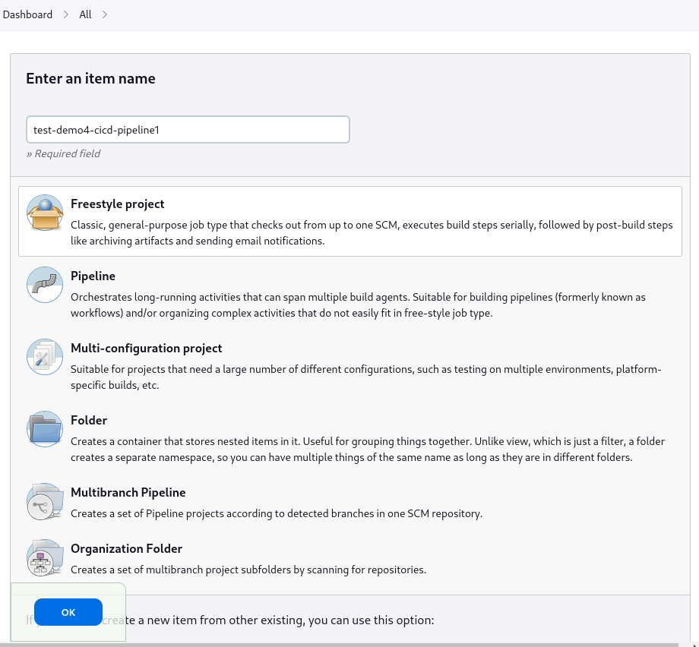

1. Scroll down to general Description add project url.Add describe as needed.

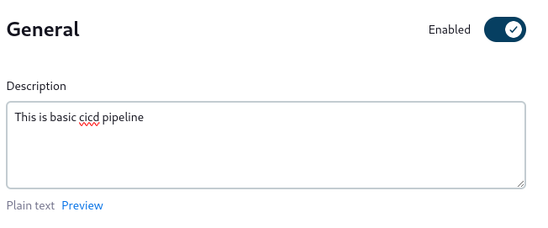

1. Choose github project and add git repo url

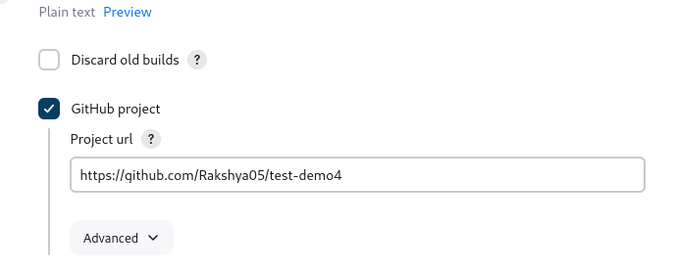

1. Scroll down to source code management and choode git, add git repository

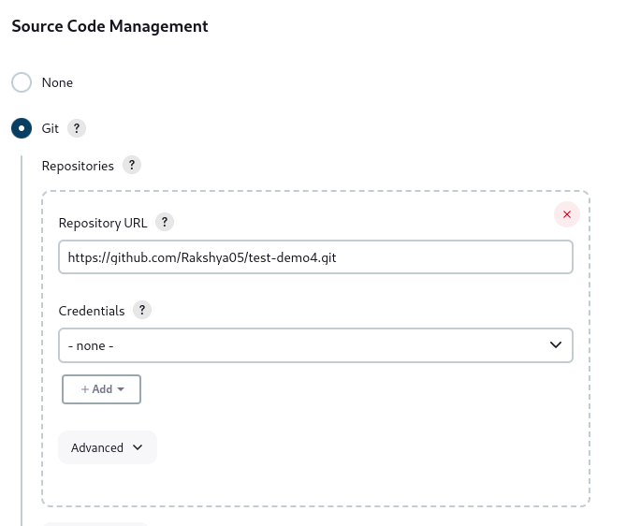

1. Remove master with main as project is running through main branch.

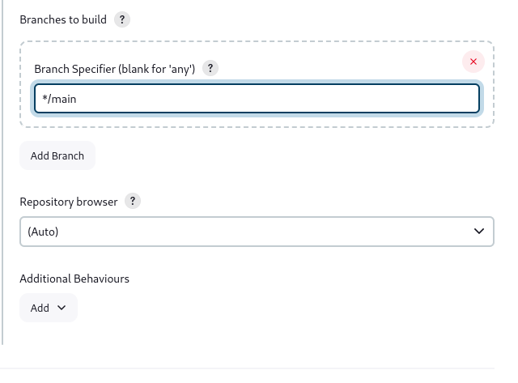

1. Add Githhub hook trigger for GITSCM for automation in build trigger.

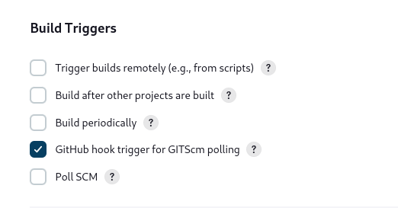

1. Choose Send files or execute commands over SSH after the build runs in build environment

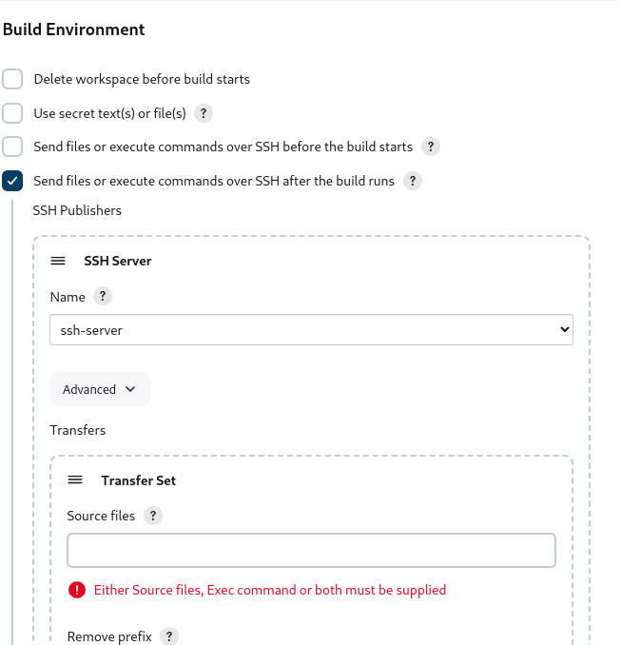

1. Add extension which is present in project in source file.For example: test-demo4 project has html,css,js ,png and jpg extensionso add all this extension in format of **/*jpeg in souce file.
2. 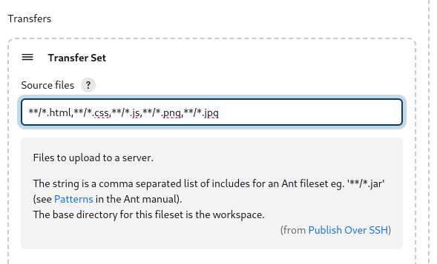
3. Add / in remote directory. It will represent the /var/www.



1. Appy and saved it.And we can see that pipeline in dashboard

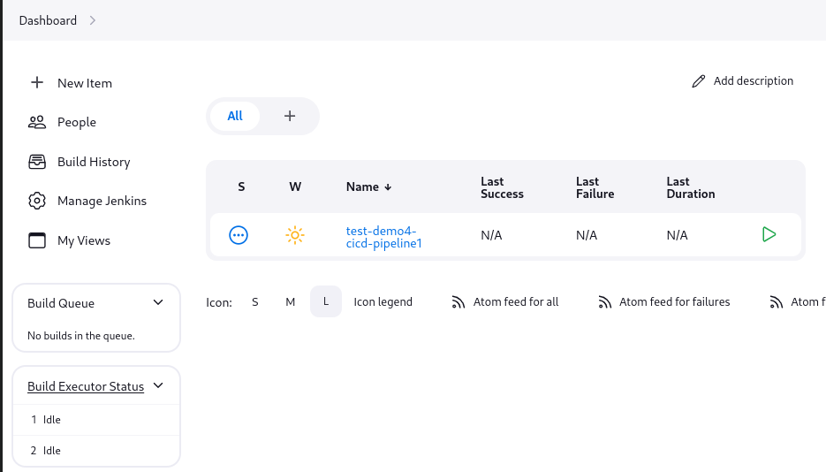

1. Now we have configure webhook for automate.So, navigate through an github setting and go through webhooks.

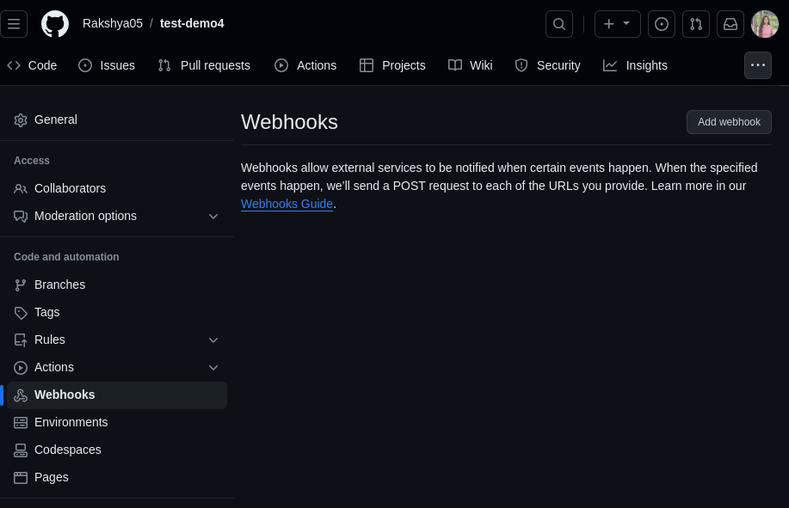

1. Select add webhook and replace payload with jenkins ip and add github-webhook at the end and add webhook.

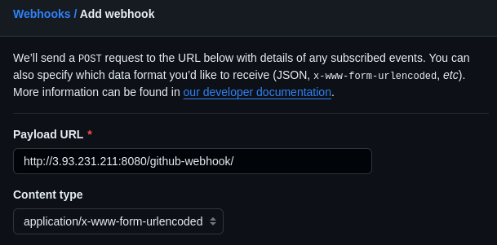

1. Now we can see our website is deployed from web server ec2 instance ip address.

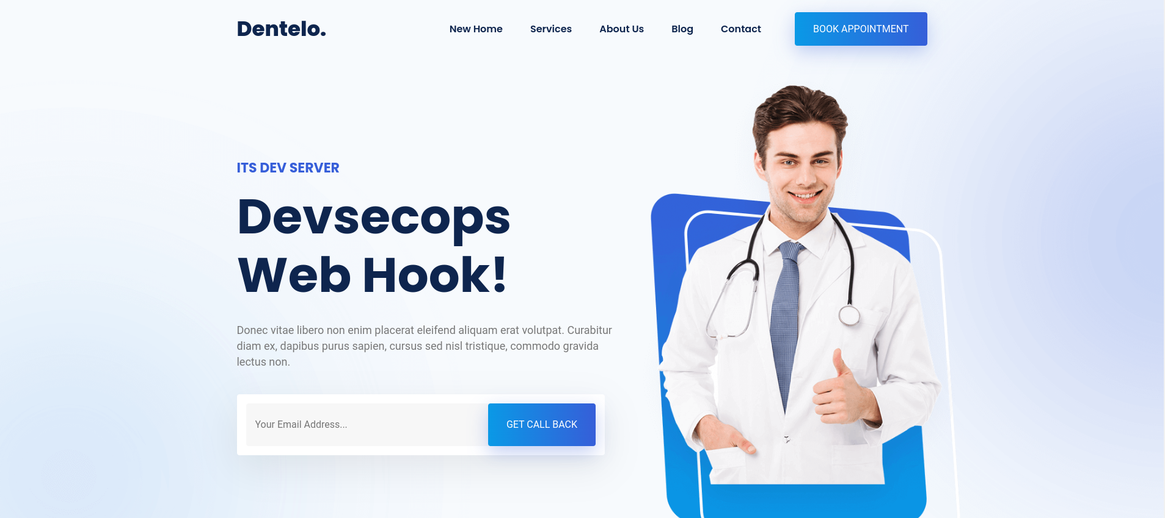

1. NOw we will change something in code and push it into github.

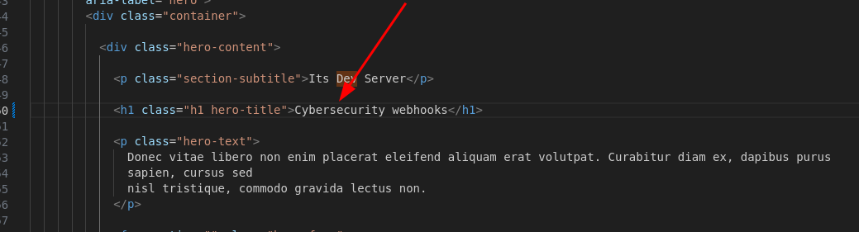

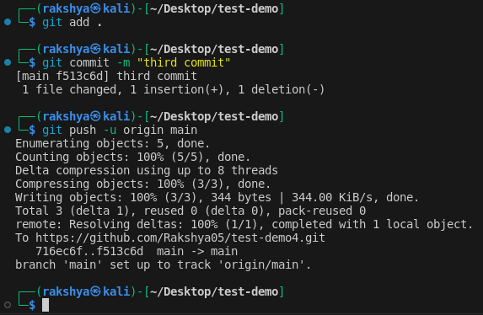

1. Website demonstration:

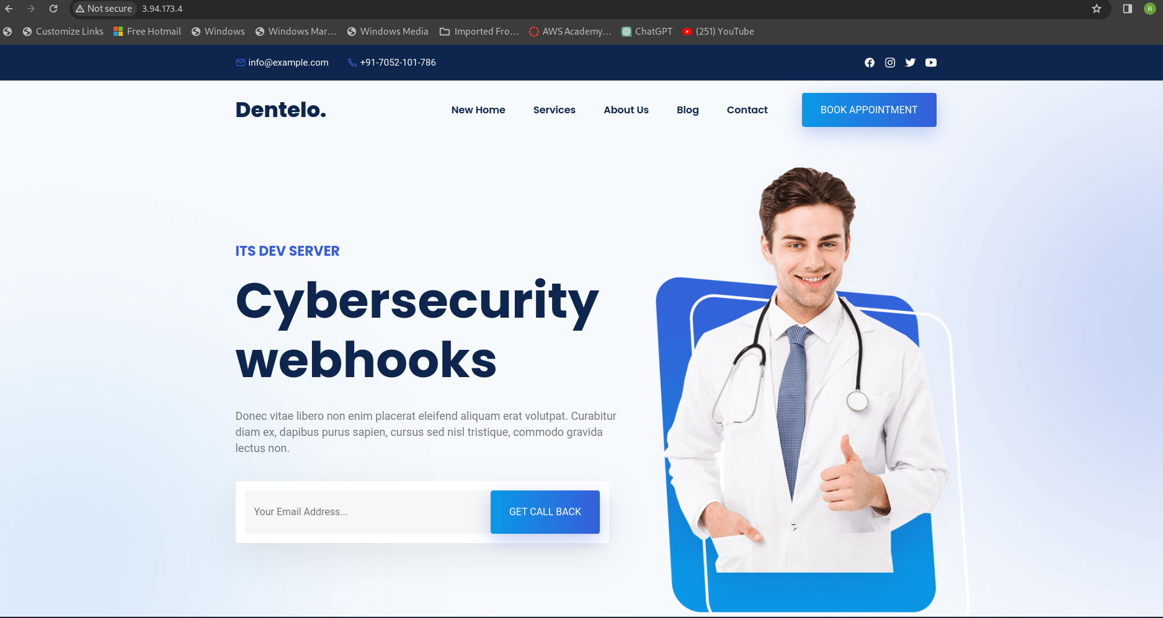

The changed applied in code is directly deployed in website. So, it is CICD cycle through jenkins